December 2018 Newsletter
Holy Cross School
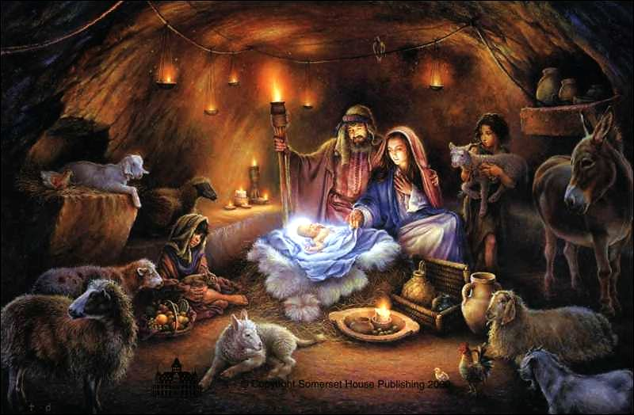

Upcoming Events

December 6
School Mass – Feast of St. Nicholas

December 7
Christmas Sale 8:30-Noon

December 13
Christmas Concert – 1pm and 7pm

Classroom Winners of the GALA Donation contest are:
K – Olivia Winter
Gr. 1 – Wesson Scherger
Gr. 2N- Yating Tan
Gr. 2CL – Irene Hong
Gr. 3 – Veda Espeut-Post
Gr. 4 – Justice Gin
Gr. 5 - Sierra Clausen-Sauter
Gr. 6 – Christian Manz
Gr. 7 – Emma Burghardt
Gr. 8 – Noah Alves

1298 Main Street Penticton, BC V2A 5G2
Holyc.com T: 250-492-4480
Dear Holy Cross Parents/Guardians

December is upon us, and we will begin to celebrate the season of Advent which begins on Sunday November 2, 2018. Being open to the Blessings and Graces of this most Holy time of year means keeping our eyes and hearts open to the needs of others and the call of Our Lord Jesus Christ. Let us greet Him together in great unity and repentance.
A short simple video to help us understand Advent: https://www.youtube.com/watch?v=eC0FGQLBp7w
Calendar for December 2018
December 4 Reconciliation 1pm
Gr. 8 basketball @ SOSS 4pm
PSG Meeting 7pm
December 6 School St. Nicholas Mass 9am
December 7 Gr. 6 Christmas sale 8:30-Noon
December 11 PSG Social 7pm
December 13 Christmas Concert 1pm and 7pm
December 18 Choir @Cherry Park 10:30-12pm
Choir & Gr. 6 @ Hamlets 1:30-2:15pm
Grade 8 Basketball @HC 4pm
December 21 Noon Dismissal – Last day before Holidays

More Important News Part 1
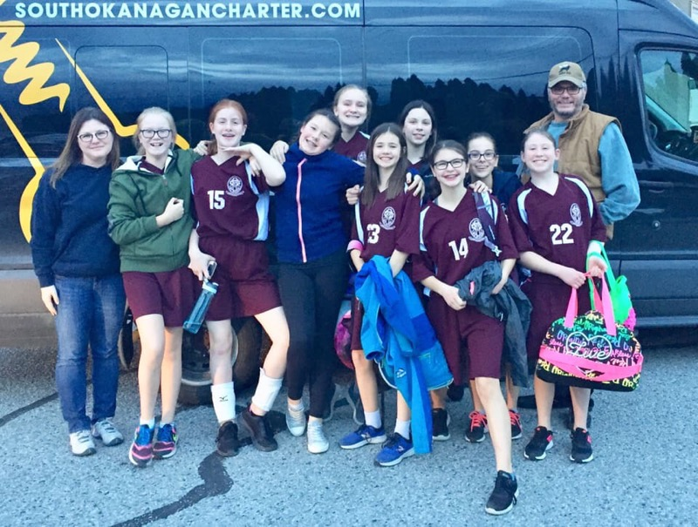

In the Community

Choir Christmas Outreach
The Choir will be informing parents of their Christmas Performances at Senior’s homes. A wonderful way of bringing some Christmas spirit into the lives of our venerable elders.

Basketball
The grade 8 teams (with a healthy number of grade 7 players) begin their season on December 4th in Oliver.
The teams play on the same Tuesdays with the schedule set up as follows:
Dec. 4 – in Oliver
Dec. 18 – Princeton and Osoyoos at home
Jan. 10 – SMS at home
Jan. 15 – KVR at home
Jan 22 – in Keremeos
Jan 29 – at Skaha Lake MS
Playoffs TBD

Greetings my name is Fr. John Kellogg. Bishop Gregory Bittman has appointed me to minister among the Indigenous communities of the Diocese of Nelson and to collaborate with the Pastors in this ministry. I thought it would be good idea to give a brief introduction of myself and a brief introduction of the plan which is titled: “Beginning a Conversation.”

I was Ordained for the Diocese of Nelson on June 7, 1987 and have served in two Parishes in the South Okanagan Deanery, two Parishes in the West Kootenay Deanery, One Parish in the North Okanagan Deanery, and the bulk of my time in six Parishes in the East Kootenay Deanery. At one time or another I have Celebrated Mass in every Parish and Mission in the Diocese. I know a great number of people here and treasure my time among you.

A “First Nations Initiative” will be offered in the Diocese for each Advent and Lent. The Advent theme will be focused on Hope and the Lenten theme will be focused on Reconciliation.

For this Advent Season there will be three bulletin/newsletter inserts for reflection. Join with your family, friends, members of parish groups that you belong to, or even those you don’t know and begin a conversation. Make it fun and enlightening. Try to find out all you can about what they think and avoid trying to convince them of something else. Other resource material will be made available and I would be happy to answer questions or give guidance as needed.

If you are inspired by something in the conversation:
- email me a brief comment at FNM@nelsondiocese.org,
- send an even briefer text to 250-317-4575, or
- talk to me in person.

Then, continue the conversation with others. Comments will be formatted and make them available with the other resources.

Bishop Bittman has offered his ongoing prayers and support as we begin and I offer my abiding prayers for all of you in this blessed Advent Season. Please offer your prayers as well and continue to participate in your regular Advent devotions and Parish offerings as we ready ourselves to celebrate the Incarnation – May Jesus be truly with you.

Fr. John Kellogg
First Nations Ministry
Diocese of Nelson
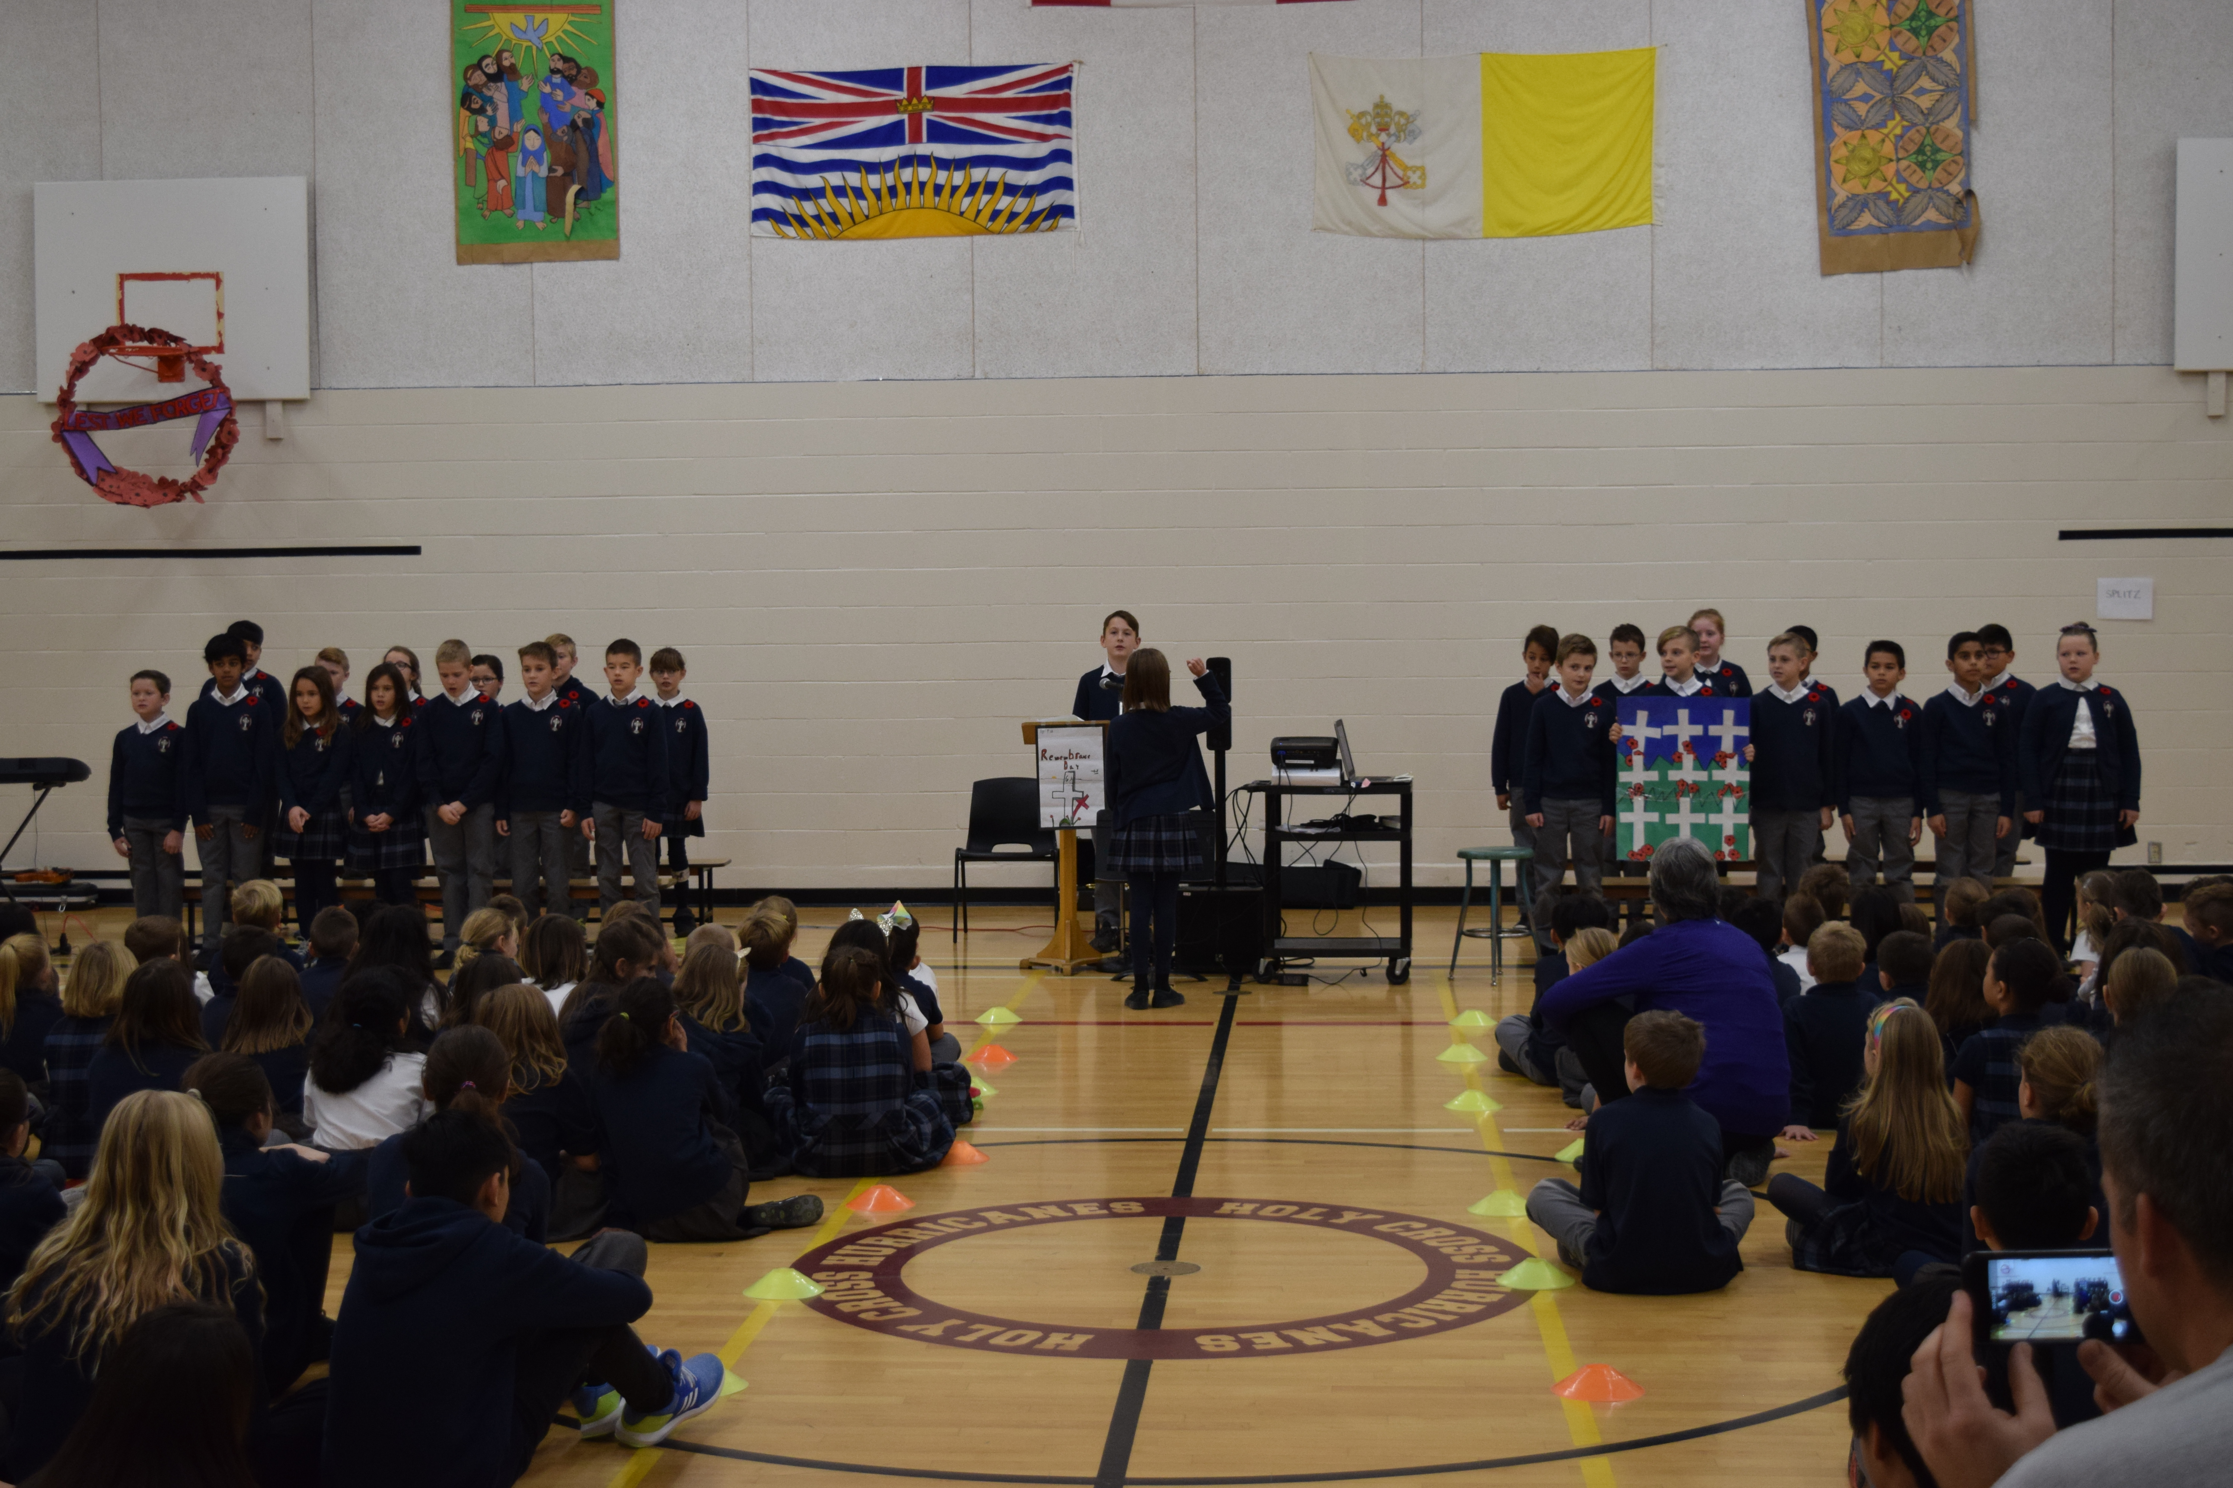

As Christmas draws near and stress builds, take a moment to remember what Christmas is and who you want the Lord to find when he comes. Here are seven ways to live mindfully this Advent:
1) Devote 5-10 minutes each day to private prayer
2) Continue (or start — it is never too late) to light the Advent wreath each day and recite a prayer
3) Go to confession
4) Listen to Advent music and save Christmas music for the Christmas season
5) Meditate on the Incarnation
6) Read the daily Mass readings
7) Read these two In Focus articles: “Rediscovering Christmas Joy” and “This Advent, stop the clock”

More Important News Part 2
The overall theme for First Nations Ministry is Respecting the Sacred. The themes for Advent will be as follows: for the first Sunday of Advent – Sacred Name, the second Sunday of Advent – Sacred Place, and the third Sunday of Advent – Sacred Time. Since the fourth week is a really short one, there are no sessions planned.
Next week the conversation will begin and suggestions will be given for each week.
Currently in our diocese, there is one First Nations Church that celebrates Mass weekly, several that have Mass monthly, one that has Mass three times a year, one twice a year, and several that have not celebrated Mass in many, many years.

This will also be the first time in our diocese that an invitation has been extended to our diocesan Catholic Schools. The BC Ministry of Education has developed a new First Nations Principles which is embedded into the curriculum and is part of the learning program in our Catholic schools. For the First Nations students attending our schools, these young members of our Catholic family will be a part of a broader conversation for a long time. We pray for healing and understanding as we all seek unity.

Many communities have very active Métis groups and we want to reach out and include them too. The richness that is ours: being served by Priests from the Philippines, India, Africa, Ireland, and North America. We are truly blessed to have this cultural diversity.

New announcements will continue until Sunday, December 16th (the Third Sunday of Advent). Each announcement will suggest a specific conversation. After your time with others there are a number of possible ways to share the results with me:

- Talk to me in person (I am visiting throughout the Diocese)
- Email me a brief comment at: FNM@nelsondiocese.org
- Send an even briefer text message to 250-317-4575
Fr. John Kellogg
First Nations Ministry
Diocese of Nelson
Please note:
- Online resources coming soon
- Next week: Session 1 – Sacred Name
First Sunday of Advent – Sacred Name

This week the conversation begins

Suggestions:
- Advent
This Sunday the first candle (purple) is lit.
- Include a prayer intention
A conversation with God can place everything that follows with all that God wants to do for us and with us. We share from our own concerns, but we want to be sure to listen to God’s compassionate response. May it be a time of special grace.
- Speak with others
Include faith in the conversation, joining with one, two or three others (or your whole family) first, then expand the conversation more broadly. Be open to their thoughts without needing to correct or convince. Really get to understand exactly what they are saying. There will be more time to react and clarify as time goes on.
- Share your experience – check out the online resources here

After your time with others there are a number of possible ways to share the results with me:

- Talk to me in person (I am visiting throughout the Diocese)
- Email me a brief comment at: FNM@nelsondiocese.org
- Send an even briefer text message to 250-317-4575

Fr. John Kellogg
First Nations Ministry
Diocese of Nelson

- Please note:
- Online Resources are available at click here
- Next week: Session 2 – Sacred Place

