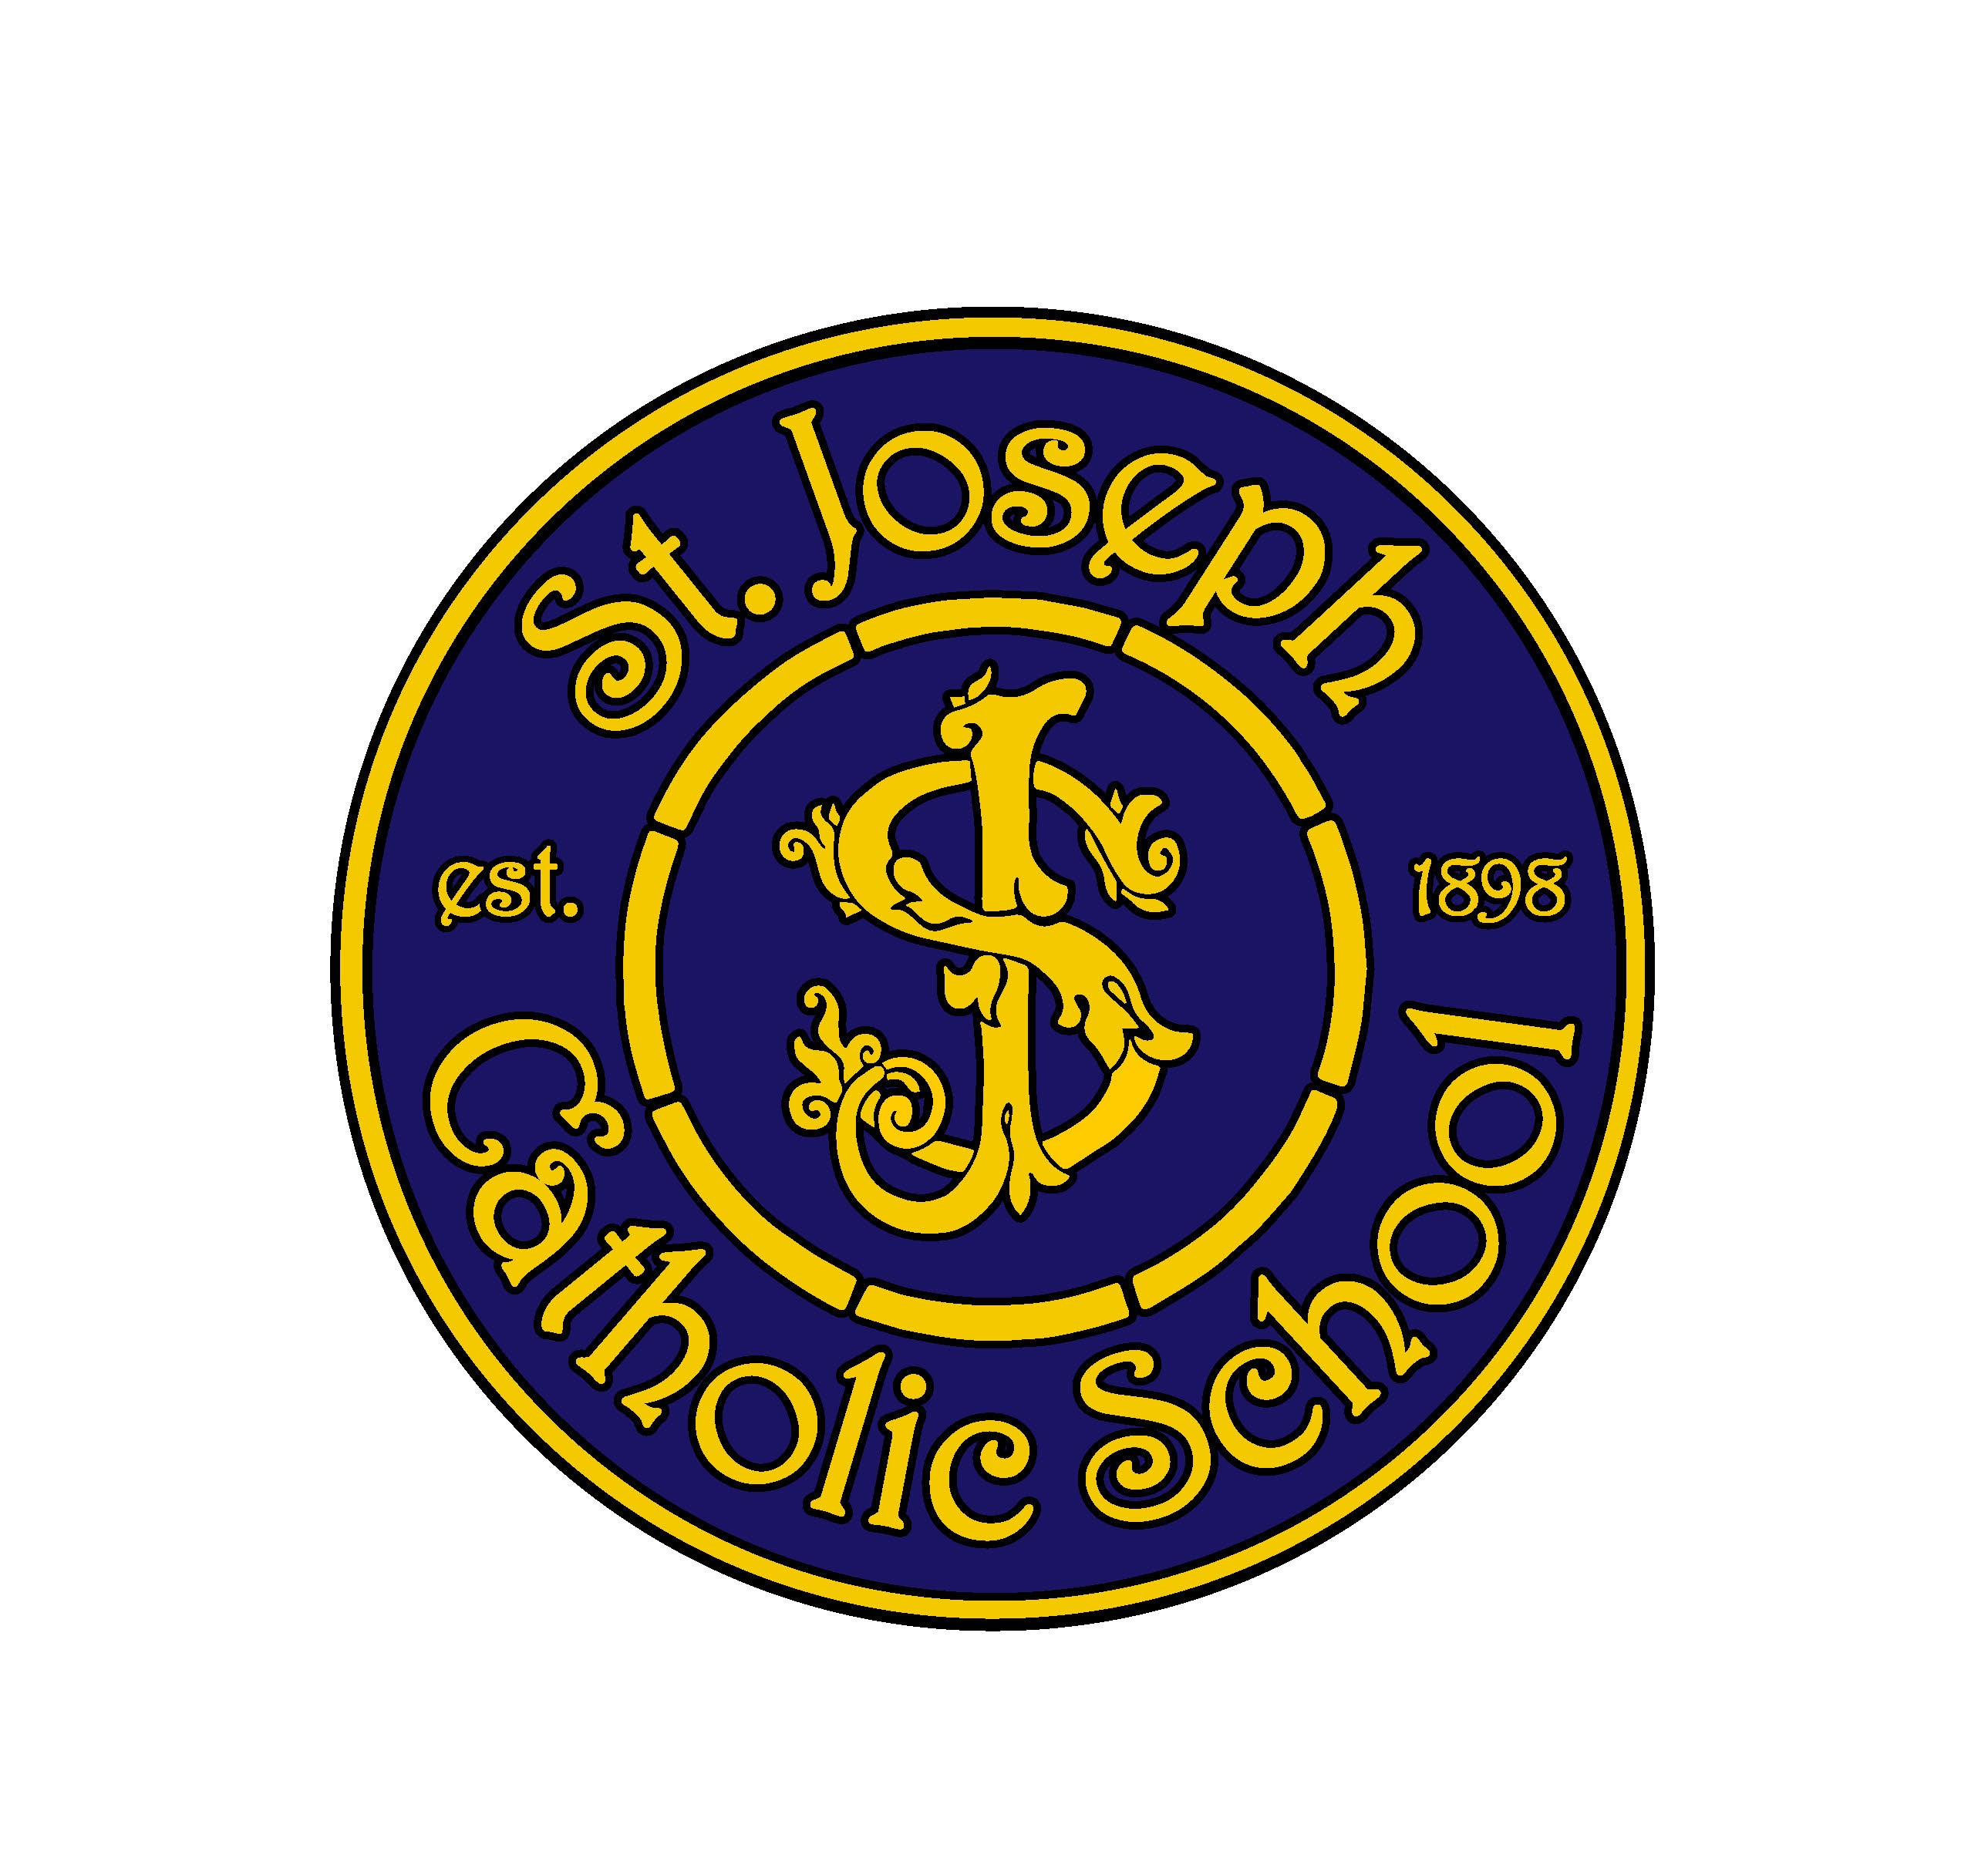
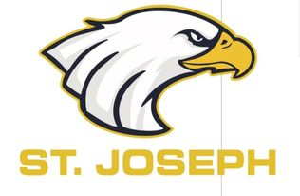
St. Joseph School
Spirit Order Form

Family Name: ______________________________________
Child’s teacher: ____________________________________
Phone number: ____________________________________

**Sweatshirts/Hoodies may be personalized
with a name on the right arm for an additional $8 per item.**
SJS logo or the new Eagle Logo available on Hoodies and shirts only. Please indicate which logo wanted on these items.
All orders must be in by October 8, 2021.
See items on back page.
 |  | Price |  | Qty |  | Personalization@ $8 |  | TOTAL$
PULLOVER HOODIES |  | $35 |  |  |  | Eagle Logo  SJS Logo
Youth S |  |  |  |  |  |  |  | $
Youth M |  |  |  |  |  |  |  | $
Youth L |  |  |  |  |  |  |  | $
Youth XL |  |  |  |  |  |  |  | $
Adult S |  |  |  |  |  |  |  | $
Adult M |  |  |  |  |  |  |  | $
Adult L |  |  |  |  |  |  |  | $
Adult XL |  |  |  |  |  |  |  | $
ZIP-UP HOODIES |  | $40 |  |  |  | SJS Logo  Eagle Logo Not available
Youth S |  |  |  |  |  |  |  | $
Youth M |  |  |  |  |  |  |  | $
Youth L |  |  |  |  |  |  |  | $
Youth XL |  |  |  |  |  |  |  | $
Adult S |  |  |  |  |  |  |  | $
Adult M |  |  |  |  |  |  |  | $
Adult L |  |  |  |  |  |  |  | $
Adult XL |  |  |  |  |  |  |  | $
 |  |  |  |  |  | TOTAL |  | $
 |  |  | Size |  |  |  | Amount |  | Total
Children’s Place Girls Uniform Sweater Dress | Size: Youth XS,S,M,L,XL,XXL  $40 |  |  |  | SJS Logo
Children’s Place Girls Uniform Ponte Knit Dress | Size: Youth  XS,S,M,L,XL,XXL  $35 |  |  |  | SJS Logo
Polo shirt | Youth and adult sizes |  |  |  | Eagle Logo  SJS Logo |  | $30
Cotton Shirts | Youth and Adult sizes |  |  |  | Eagle Logo  SJS Logo |  | $25
Baseball hat | One size |  |  |  | SJS Logo |  | $20
Toques | One size |  |  |  | SJS logo |  | $20
Flat brim hat | One size |  |  |  | SJS Logo |  | $25
Mask |  |  |  |  | SJS Logo |  | $10
Patch |  |  |  |  | SJS Logo |  | $10
 |  |  |  |  |  |  | TOTAL |  | $

All orders must be in by October 8, 2021.

Payment made in full by chq St. Joseph PSG, e-transfer to etransfersjsnelsonpsg@gmail.com or cash.
Sample pictures of Logo’s and Spirit wear are on the SJS website.
https://stjosephnelson.ca/st-joseph-spirit-wear.php

Any questions contact Becky @ 250-551-5081

